1st Floor
17 Baker Street
Rosebank
Johannesburg
South Africa
2196
Tel: +27 (0) 11 442 2434
Fax: +27 (0) 11 442 2454

ROACH 2 Chassis Thermal Analysis for everything on:
Following was used throughout unless change stated in scenario:

Inlet Pressure 0Pa Gauge
Inlet Temperature 25 Degrees Celsius
Outlet Pressure 0Pa Gauge

FPGA x1 0W
PowerPC x1 5W
ADC x2 0W
ROACH PHY x2 1W
ROACH PCB x1 1W
CPLD x1 0.3W
Flash x1 0.3W
RAMDIMM x1 0W
QDR x4 0W
Power Modules x3 2W
SFP PHY x4 0W
DDR2 x4 0.8W
1v0 x1 4W
Power Supply x1 1.2W

Scenario 1 Fans 5000 RPM:
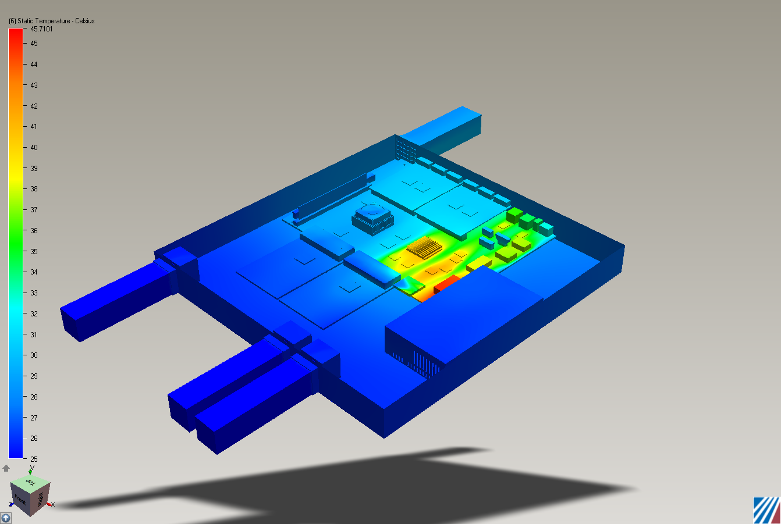

Scenario 2 Fans 6000 RPM:
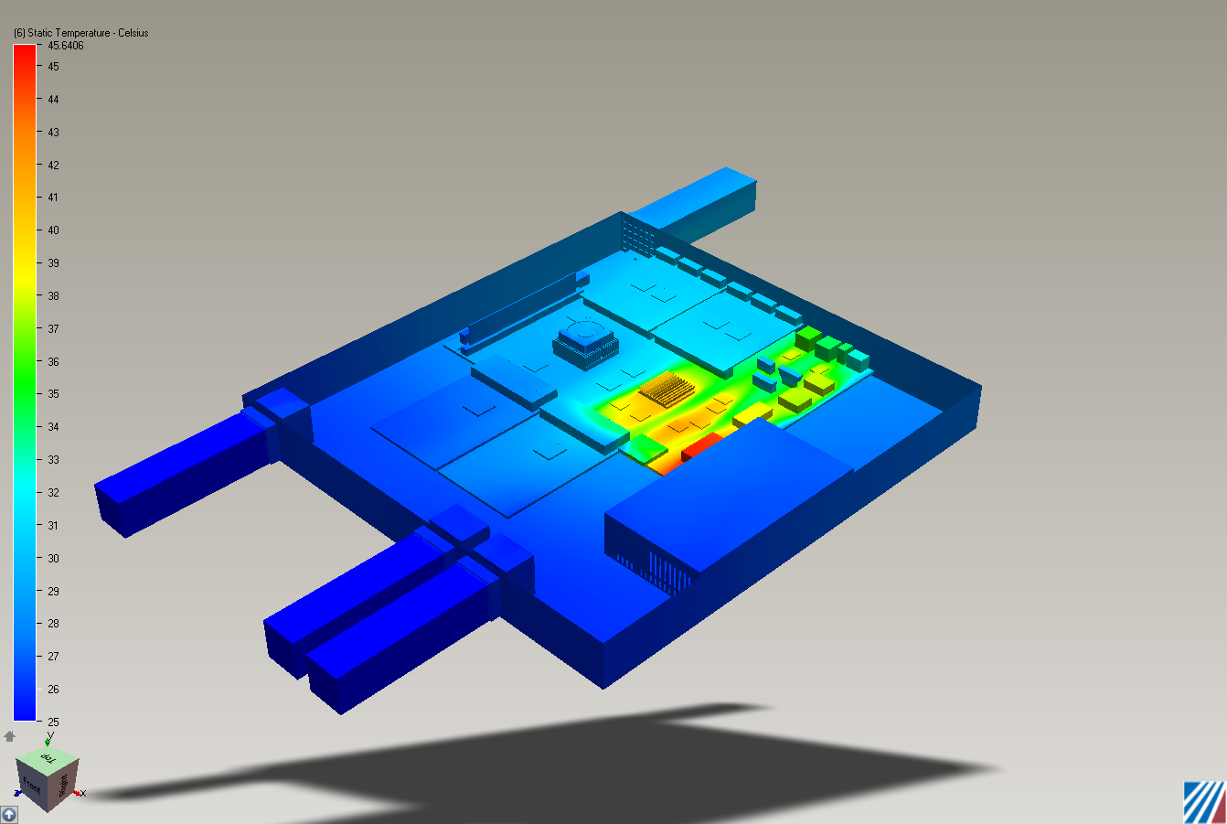

Scenario 3 Fans 7000 RPM:
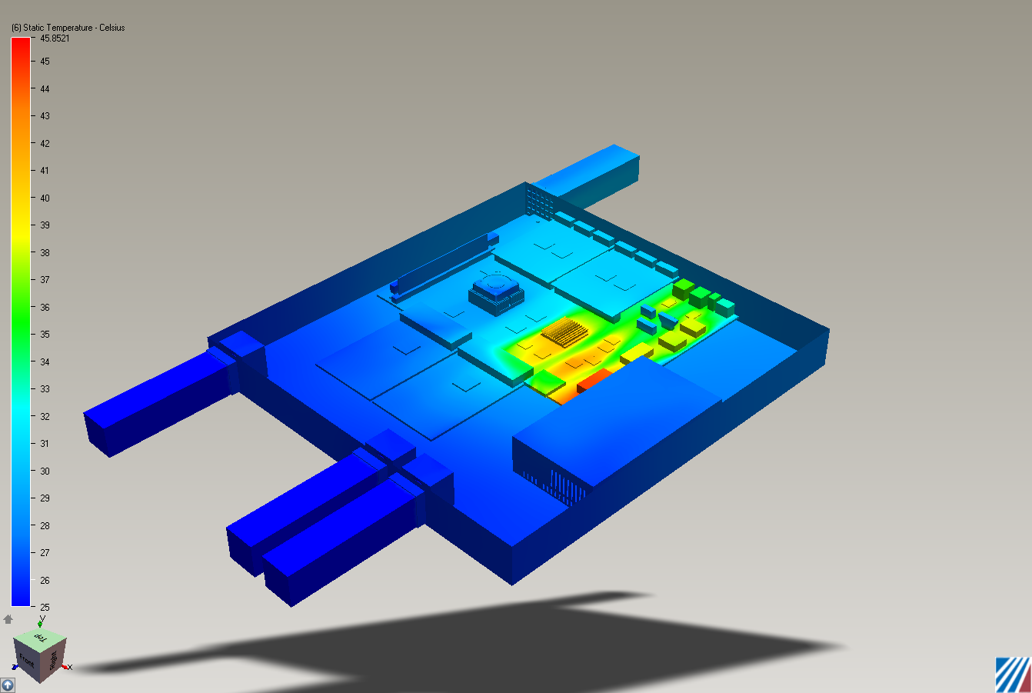

Scenario 4 Fans 8000 RPM:
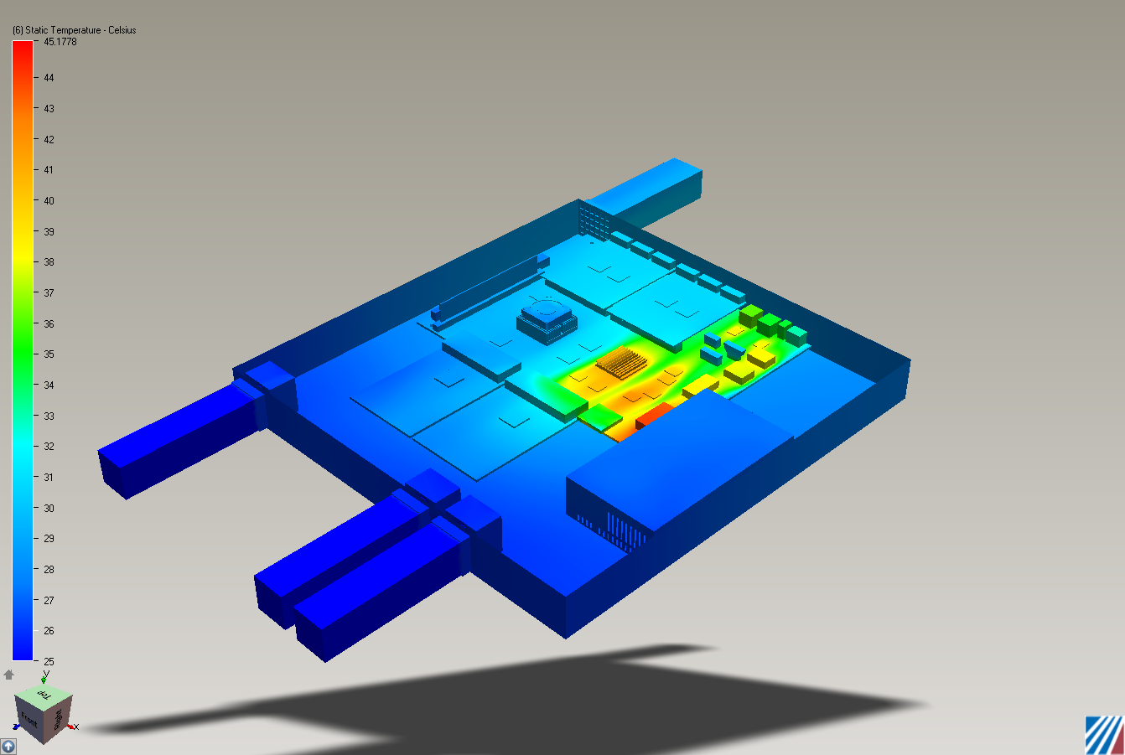

Scenario 5 Fans 9000 RPM:
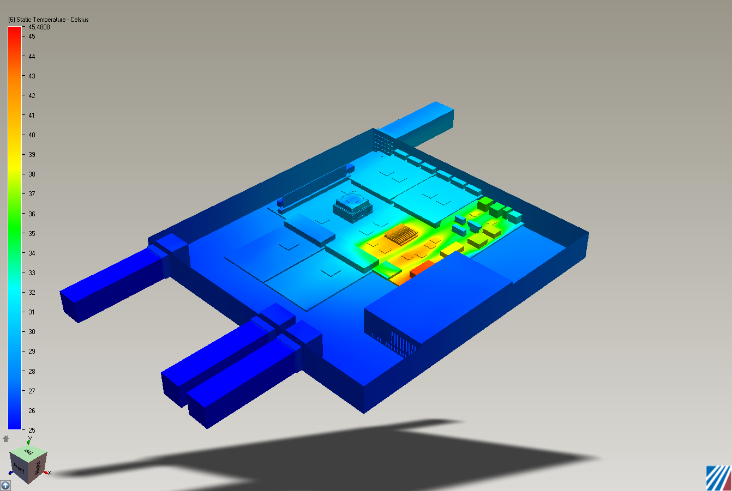

Scenario 6 Fans 10000 RPM:
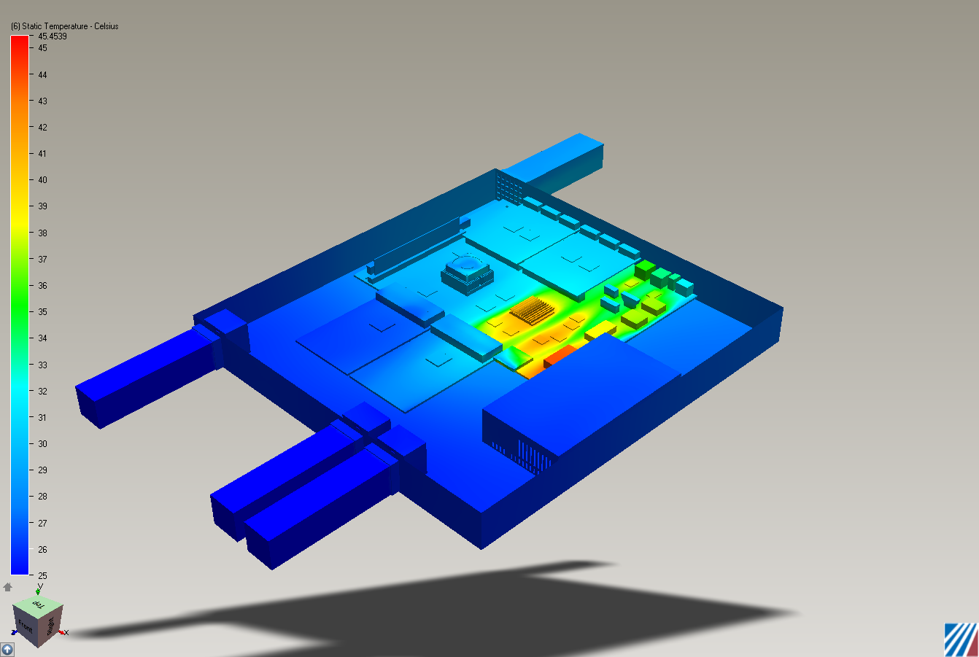

Scenario 7 Fans 11000 RPM:
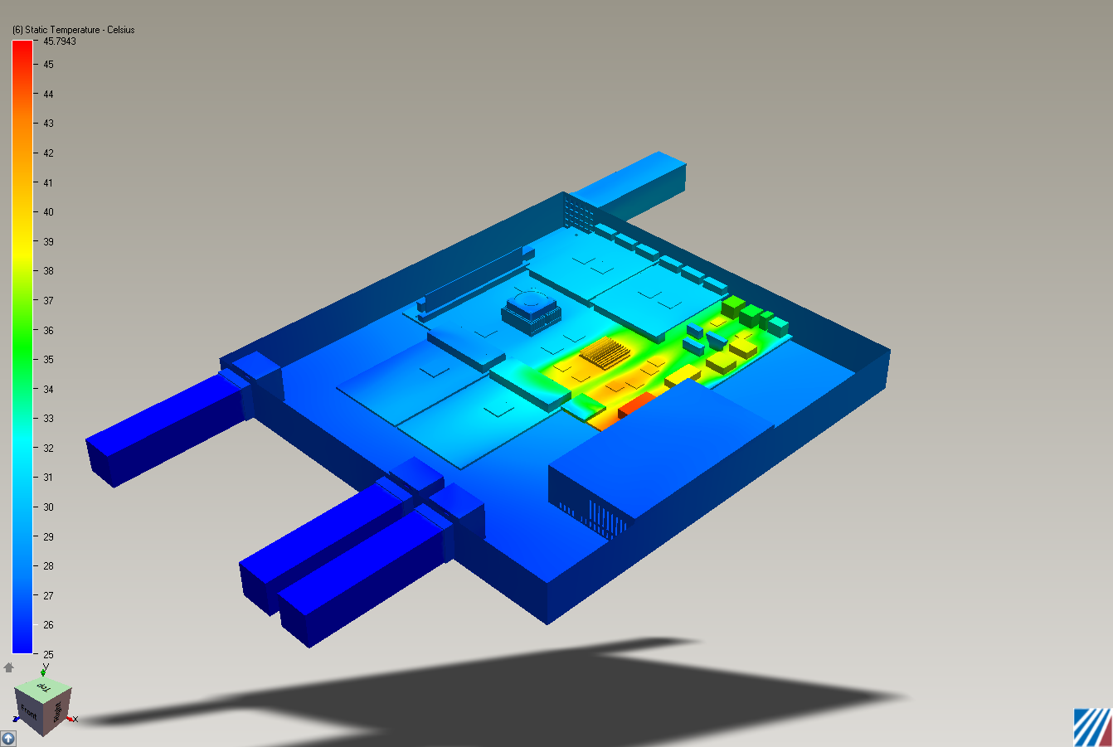

Scenario 8 Fans 12000 RPM:
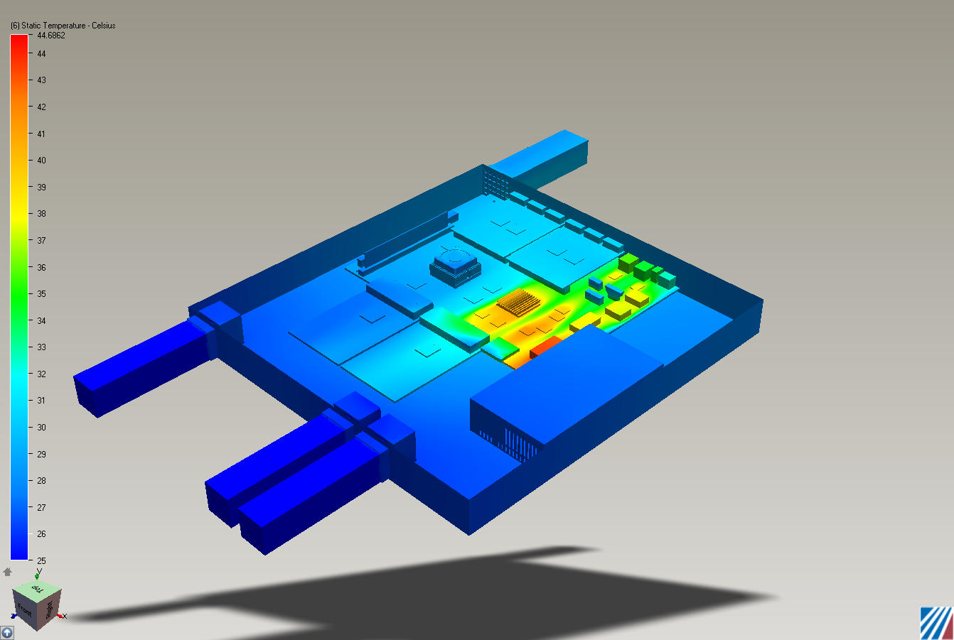

Comments:
The fan speed doesn’t seem to be making too much difference to the cooling at this level. I shall run more sims taking the speed down further. I am speculating that the fan curve is the reason for the slight discrepancies in the temperature.

